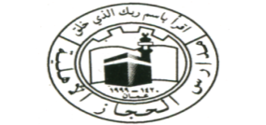 | AL –Hijaz Secondary Schools
Grade: 5 | English Weekly Plan ( 2018/2019) The First Semester.  from  (Sunday 11th Nov. 2018) to (Thursday 15th Nov . 2018) | English Language department
Teacher will cover
Action Pack:
Writing: Write about any shape and draw it in your action notebook. ( from 4 to 6 lines )
Science
Bring balloons

Sunday | Unit 3 page 40  Tunnels and bridges
Monday | Second Writing Exam  WB page 21
Tuesday | Unit 3 page 41  Tunnels and bridges
Wednesday | WB page (22 – 23) + PB page 42
Thursday  Note: Prepare for Unit 3 | Booklet page 22

