

**The Hashemite Kingdom of Jordan**

**The Ministry of Education**

**AL-Hijaz Private Schools**

**Quality Assurance Section**

**WorksheetNo. (3)**

|  |  |  |  |
| --- | --- | --- | --- |
| **Day:** | **Year: 2019 / 2020** | **Subject: English** | **Student’s Name:** |
| **Date: -9-2019** | **Semester: 1st** | **Topic: verb** | **Grade & Section:(4) A-B-C** |

***An action verb is a word that shows what someone or something is doing.***

*Examples: Mary sleeps on the couch.*

*Ken and his mother cook dinner.*

**Action words (verbs)**

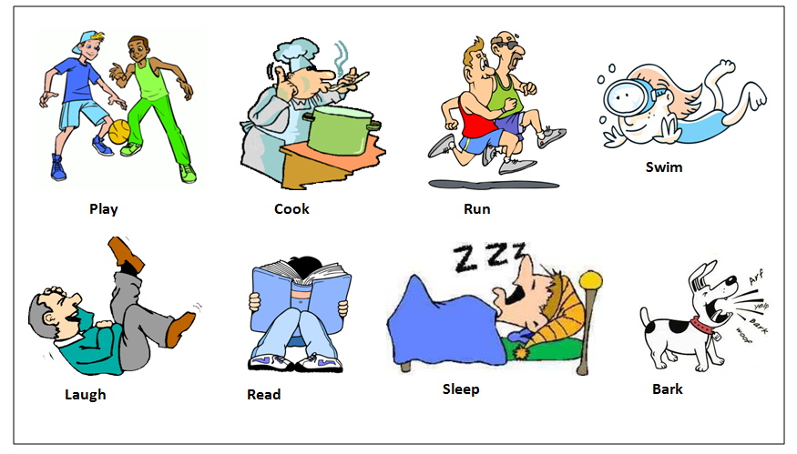

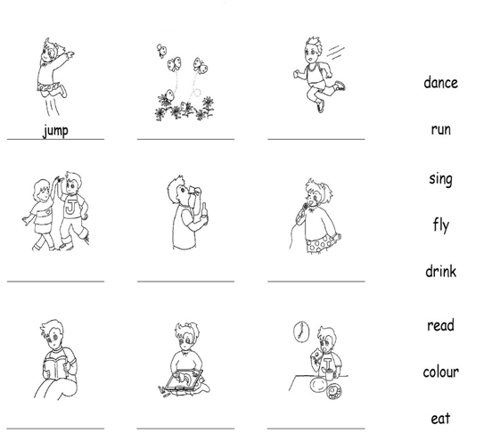**Write the suitable verbs under each picture.**

Teacher: - Hala AL-Azzah