 | Al Hijaz Private Schools │ CP Section |  | 
Name: ________________________________  Grade: ( 1 ) a , b |  | Phonics worksheet # (34 ) | Teacher: Rawan
* Practise saying and writing the following sounds:
V v /v/
  vet | 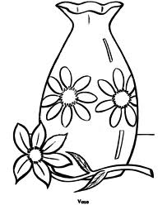  vase
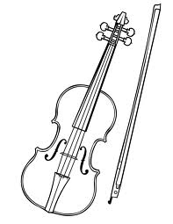  violin | 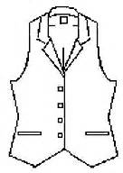  vest
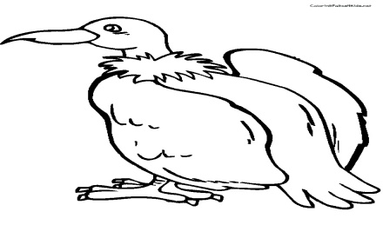  vulture | 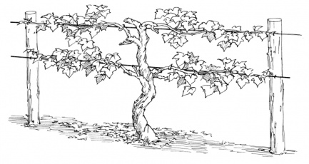  vine

 | Al Hijaz Private Schools │ CP Section
Name: ________________________________  Grade: ( 1 ) a , b |  | Subject worksheet # (35 ) | Teacher:Rawan
* Practise saying and writing the following sounds:
Z z /z/

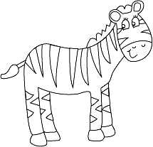  zebra | 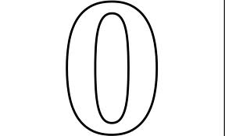  zero
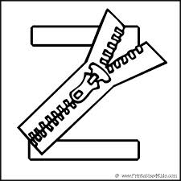  zipper | 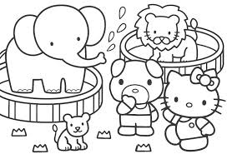  zoo
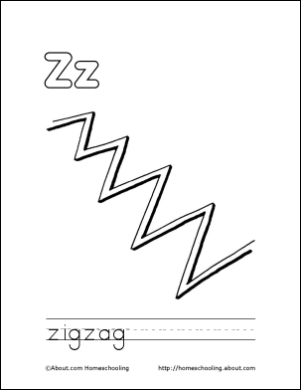  zigzag | 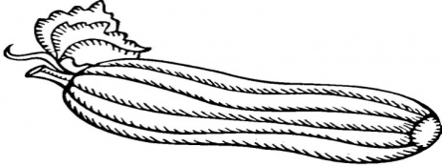  zucchini

 | Al Hijaz Private Schools │ CP Section
Name: ________________________________  Grade: ( 1 ) a , b |  | phonics worksheet # ( 38 ) | Teacher: Rawan
* Practise saying and writing the following sounds:
Q q /kw/

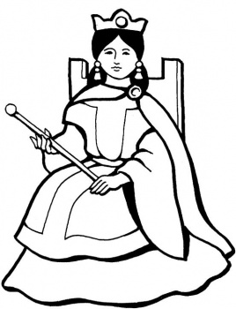  queen |   question
  quarter | 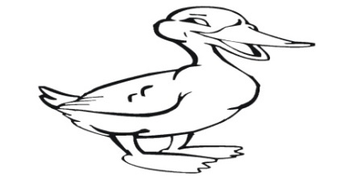  quack
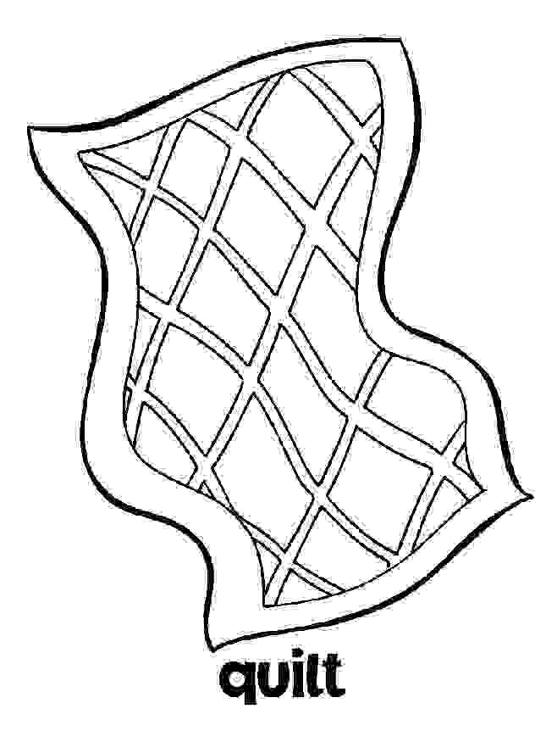 | quilt

 | Al Hijaz Private Schools │ CP Section
Name: ________________________________  Grade: ( 1 ) a , b |  | phonics worksheet # ( 37 ) | Teacher: Rawan
* Practise saying and writing the following sounds:
U u /ŭ/

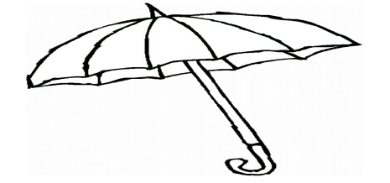  umbrella | 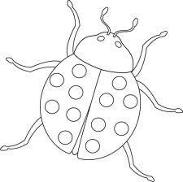  bug
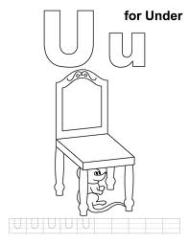  under |   sun
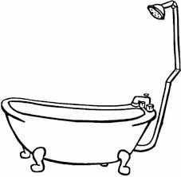  tub |   up

