 | Al Hijaz Private Schools │ CP Section |  | 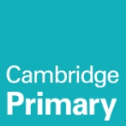
Name: ________________________________  Grade: ( 1 ) a , b |  | Phonics worksheet (40 ) | Teacher: Rawan

Spelling list (1)
1. can I can help you build a sand castle.
2. cat Our cat likes to purr.
3. back Please come back soon.
4. dad My mom and dad are home.
5. am I am going to see a movie tonight.
6. bat Swing the bat and hit the ball.
7. mad He stopped being mad at his brother.
8. ran The dog ran after the ball.
9. sack Bring your lunch in a paper sack.
10. at I will see you at school.

