The Ministry of Education
Al- Hijaz Schools | International Section
Semester 2
2013 / 2014
Name : _________________  Date : _________________ | Revision Sheet | Subject : Mathematics  Grade: 3

Chapter 7: Division Concepts and Facts
Question (1): Solve:

27 ÷ 9 = | 49 ÷ 7 = | 81 ÷ 9 = | 7 ÷ 7 =
8÷ 1 = | 24 ÷ 8 = | 0 ÷ 9 = | 36 ÷ 9 =

Question (2): Find each quotient and remainder.

11 ÷ 4 = R | 5 ÷ 3 = R | 11 ÷ 9 = R
Question (3): Complete the following fact family:

3 × = 24 24 ÷ = 3

8 × 3 = 24 ÷ = 8

Question (5): Henry has 20 apples and wants to put the same number of apples in each of 5 baskets. Draw a picture of this story and write the division sentence. How many apples will he put in each basket?

___________________________________________________________________________________________________________________________________________________________________________.

Chapter 8: Geometry and measurement
Question (4): Name the solid figure that each object looks like.

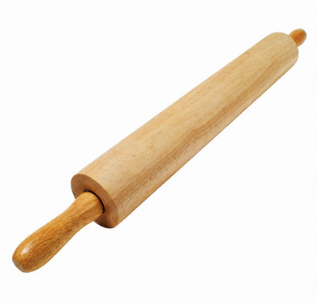

Question (4): Look at the following figure then answer the questions:

- What we call this figure?
________________________________
- How many faces for it?
________________________________
- How many edges for it?
________________________________
- How many vertices for it?
________________________________

Question (5): Circle the figures that represent a polygon:

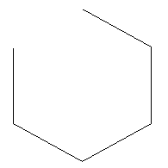

Question (6): Draw the following:
Note: Draw with your ruler (bring your ruler on Thursday for the exam)

Line | Acute Angle | Right triangle
Ray | Trapezoid | Square
Parallelogram | Point | Cylinder
Question (7): Who am I????
I am a quadrilateral with four right angles and four equal sides. Who am I?????
__________________________________.

