|  |  |  |
| --- | --- | --- |
|  | **The Ministry of Education**  **Al- Hijaz Schools / International Section**  **Semester 1**  **2015 / 2016** | logo-trans |
| **Name : _________________**  **Date : _________________** | **Seasons of the year** | **Class: 1 ( A B )** |

**Fill in the blanks with the name of the correct season:**

[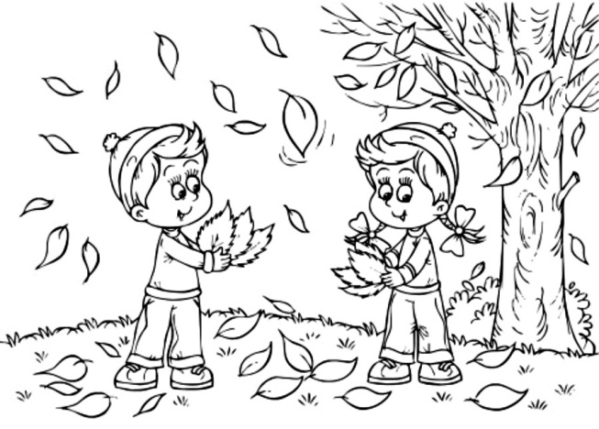](http://www.google.jo/url?sa=i&rct=j&q=&esrc=s&frm=1&source=images&cd=&cad=rja&uact=8&ved=0CAcQjRxqFQoTCIz6gaeql8kCFYY7FAod_1sL7w&url=http://koloringpages.com/fall-coloring-pages/&bvm=bv.107467506,d.d24&psig=AFQjCNGnnjuAw9jNDJ9MO_P2X9cZzfSdwQ&ust=1447845326303070)[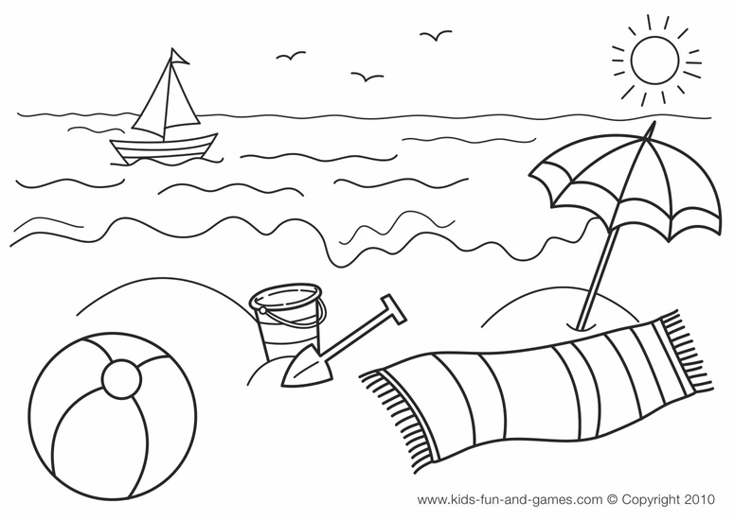](http://www.google.jo/url?sa=i&rct=j&q=&esrc=s&source=images&cd=&cad=rja&uact=8&ved=0CAcQjRxqFQoTCI_w_dafl8kCFYo4FAod9GsLtg&url=http://kidsgamescentral.com/summer-coloring-pages.html&psig=AFQjCNHPyeTrjF41reGYclJ5jbx81Onc4w&ust=1447842456472356)

|  |  |  |  |
| --- | --- | --- | --- |
| summer | fall | winter | spring |

[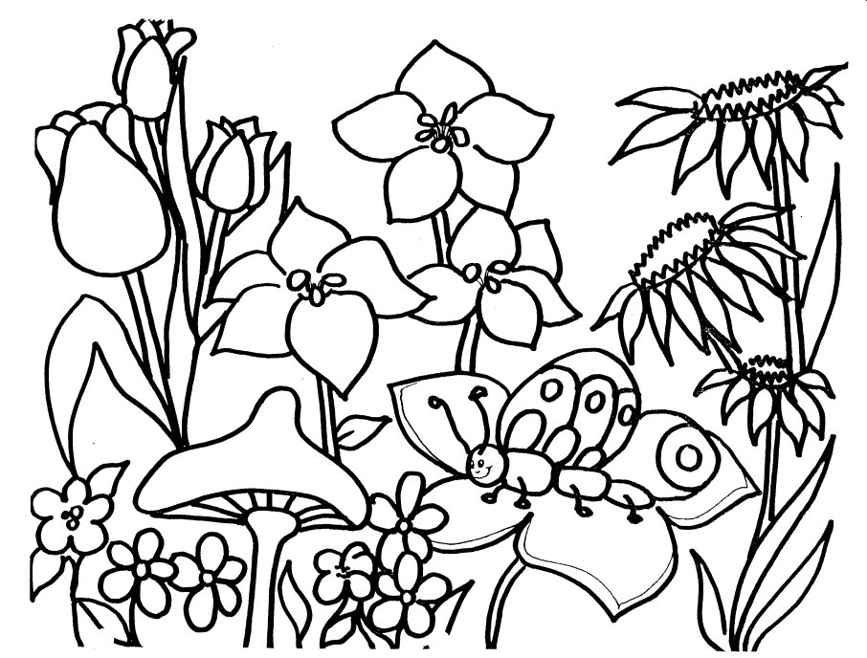](http://www.google.jo/url?sa=i&rct=j&q=&esrc=s&frm=1&source=images&cd=&cad=rja&uact=8&ved=0CAcQjRxqFQoTCOn4o7Gpl8kCFYU-FAodxfoDwg&url=http://icartoonwallpapers.tk/printable-spring-coloring-sheets.html&bvm=bv.107467506,d.d24&psig=AFQjCNHyorTzOjupfmzc_uGa5i8vo51QYw&ust=1447845079079937)[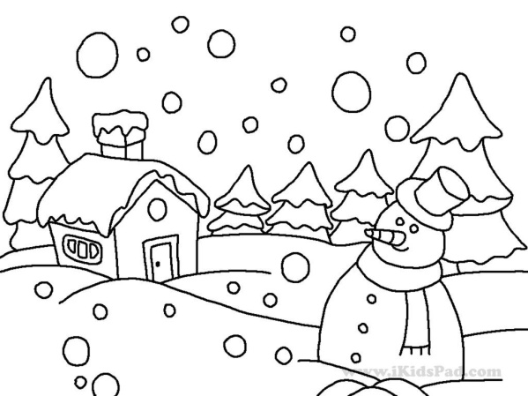](http://www.google.jo/url?sa=i&rct=j&q=&esrc=s&source=images&cd=&cad=rja&uact=8&ved=0CAcQjRxqFQoTCJDDlfmel8kCFYbtFAodnAoI7A&url=http://koloringpages.com/winter-coloring-pages/&psig=AFQjCNFhkfh5tQpxgGQcOeeLaEOfYasTVQ&ust=1447842229222861)

|  |  |  |
| --- | --- | --- |
|  | **The Ministry of Education**  **Al- Hijaz Schools / International Section**  **Semester 1**  **2015 / 2016** | logo-trans |
| **Name : _________________**  **Date : _________________** | **Use of English**  **Adjectives** | **Class: 1 ( A B )** |

**Adjectives which show feelings:**

|  |  |  |
| --- | --- | --- |
| I am **happy** . | I am **sad**. | I am **angry**. |
| [http://f1.lodozo.com/us-en/files/images/happy-face-lodozo.com.jpg](http://www.google.jo/url?sa=i&rct=j&q=&esrc=s&frm=1&source=images&cd=&cad=rja&uact=8&ved=0CAcQjRxqFQoTCJbG8vKul8kCFQhwGgode2kPCg&url=http://lodozo.com/us-en/?attachment_id=374964&bvm=bv.107467506,d.d2s&psig=AFQjCNGiAoF6gVCjPxXro0SQTJYcqgjtXA&ust=1447846558271831) | [http://vignette4.wikia.nocookie.net/icarly/images/3/37/Sad-face.png/revision/latest?cb=20120729221450](http://www.google.jo/url?sa=i&rct=j&q=&esrc=s&frm=1&source=images&cd=&cad=rja&uact=8&ved=0CAcQjRxqFQoTCOPI2uKul8kCFYvXGgodmGEGoQ&url=http://icarly.wikia.com/wiki/File:Sad-face.png&bvm=bv.107467506,d.d2s&psig=AFQjCNHj45MGYLCiLwCxH_04LgNKEf-IiQ&ust=1447846524726135) | [http://pix.iemoji.com/images/emoji/apple/8.3/256/angry-face.png](http://www.google.jo/url?sa=i&rct=j&q=&esrc=s&frm=1&source=images&cd=&cad=rja&uact=8&ved=0CAcQjRxqFQoTCPrhhYWvl8kCFYkTGgodtBgCFQ&url=http://www.iemoji.com/view/emoji/29/people/angry-face&bvm=bv.107467506,d.d2s&psig=AFQjCNHcOkAGPAKUzjr9GMtfOGSjyfuSQg&ust=1447846588319040) |

**Adjectives which show "how many"**

|  |  |
| --- | --- |
| I have **three** flowers. | There are **four** bags in the room. |
| [http://www.clker.com/cliparts/7/n/2/4/A/H/three-colorful-flowers-md.png](http://www.clker.com/clipart-three-colorful-flowers.html) | http://previews.123rf.com/images/yaviki/yaviki1108/yaviki110800016/10436467-The-four-color-paper-bags-Stock-Vector-shopping-bags-bag.jpg |

**Adjectives which show the color :**

|  |  |  |
| --- | --- | --- |
| I have a **yellow** skirt. | I have a **red** hat. | I have a **green** scarf. |
| [http://www.polyvore.com/cgi/img-thing?.out=jpg&size=l&tid=125587084](http://www.google.jo/url?sa=i&rct=j&q=&esrc=s&frm=1&source=images&cd=&cad=rja&uact=8&ved=0CAcQjRxqFQoTCNPMmsivl8kCFcw_FAodVgsE2A&url=http://www.polyvore.com/disney/collection?id=4648087&bvm=bv.107467506,d.d24&psig=AFQjCNFSJdOf3mh21FxG-1m2oD7qZpWYnA&ust=1447846739463792) | [http://www.clipartbest.com/cliparts/jRT/GBG/jRTGBGkiL.gif](http://www.google.jo/url?sa=i&rct=j&q=&esrc=s&frm=1&source=images&cd=&cad=rja&uact=8&ved=0CAcQjRxqFQoTCOaPoNevl8kCFUdyFAodYKYKXQ&url=http://www.clipartbest.com/red-hat-society-clip-art&bvm=bv.107467506,d.d24&psig=AFQjCNHS538ZSaKRTQyrZxvnpbd2uuq0KA&ust=1447846771075935) | C:\Users\User\Desktop\imagesCA3GSUSI.jpg |

**Adjectives which show the size:**

|  |  |  |  |
| --- | --- | --- | --- |
| We live in a **big** house. | I see a **small** insect. | She is a **short** girl. | He is a **tall** boy. |
| [http://www.clipartlord.com/wp-content/uploads/2013/03/house4.png](http://www.google.jo/url?sa=i&rct=j&q=&esrc=s&frm=1&source=images&cd=&cad=rja&uact=8&ved=0CAcQjRxqFQoTCIHr0u2vl8kCFUZGFAodHUkNTA&url=http://www.clipartlord.com/free-big-house-clip-art/&bvm=bv.107467506,d.d24&psig=AFQjCNHSxFiZMpwo-sMJbz86cLKO7p9c6g&ust=1447846816710355) | [http://www.clker.com/cliparts/3/9/0/7/11970997651552204731johnny_automatic_chafer_bug.svg.med.png](http://www.google.jo/url?sa=i&rct=j&q=&esrc=s&frm=1&source=images&cd=&cad=rja&uact=8&ved=0CAcQjRxqFQoTCLL2hYmwl8kCFYK3FAod30ECQQ&url=http://www.clipartsheep.com/clip-art-insect-exterminator-fotosearch-search-clipart/dT1hSFIwY0RvdkwyTnZiWEJ6TG1admRHOXpaV0Z5WTJndVkyOXRMMk52YlhBdlUxVkZMMU5WUlRFd05TOXBibk5sWTNRdFpYaDBaWEp0YVc1aGRHOXlYMzVVVDBKWE1ERTNPQzVxY0djfHc9MzEwfGg9MzcwfHQ9anBlZ3w/&bvm=bv.107467506,d.d24&psig=AFQjCNHRw4v7i1wCZtM6AG-ZCIVJeKU3ww&ust=1447846859535101) | [http://www.cliparthut.com/clip-arts/709/little-girl-cartoon-characters-709949.jpg](http://www.google.jo/url?sa=i&rct=j&q=&esrc=s&frm=1&source=images&cd=&cad=rja&uact=8&ved=0CAcQjRxqFQoTCMGs7b6wl8kCFcnVFAodR0kMRA&url=http://www.cliparthut.com/dorm-girls-clipart.html&bvm=bv.107467506,d.d24&psig=AFQjCNE9ElZZVjaLxI69njkZayk1hv0lKQ&ust=1447846961507074) | [http://comps.canstockphoto.com/can-stock-photo_csp14380257.jpg](http://www.google.jo/url?sa=i&rct=j&q=&esrc=s&frm=1&source=images&cd=&cad=rja&uact=8&ved=0CAcQjRxqFQoTCKWXqp-wl8kCFUe5FAodi_IP8Q&url=http://www.canstockphoto.com/a-tall-boy-standing-14380257.html&bvm=bv.107467506,d.d24&psig=AFQjCNF3U4iVKnzDk5rGBdh6LF5nCWn1lQ&ust=1447846914861918) |

**Other adjective:**

|  |  |
| --- | --- |
| I have an **old** pants. | I buy a **new** pants. |
| [http://previews.123rf.com/images/lineartestpilot/lineartestpilot1401/lineartestpilot140104746/24826272-cartoon-patched-old-jeans-Stock-Vector.jpg](http://www.google.jo/url?sa=i&rct=j&q=&esrc=s&source=images&cd=&cad=rja&uact=8&ved=0ahUKEwiU5_7t4MbJAhUH7xQKHa-VAFYQjRwIBw&url=http%3A%2F%2Fwww.123rf.com%2Fphoto_24826272_cartoon-patched-old-jeans.html&bvm=bv.108538919,d.d24&psig=AFQjCNFXX-0kQddsdZk9v2W5fMDBfKDNgA&ust=1449474865964054) | [http://cdn-0.freeclipartnow.com/d/17140-1/trousers.jpg](http://www.google.jo/url?sa=i&rct=j&q=&esrc=s&source=images&cd=&cad=rja&uact=8&ved=0ahUKEwiIioqi4cbJAhVFaxQKHYbNCDUQjRwIBw&url=http%3A%2F%2Fwww.freeclipartnow.com%2Ffashion%2Fpants%2F&psig=AFQjCNHx5zp9TIQaEh-uxQFUr3BTDXBYFw&ust=1449474985688032) |

[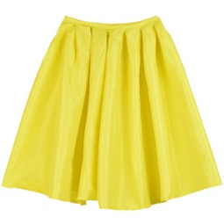](http://www.google.jo/url?sa=i&rct=j&q=&esrc=s&frm=1&source=images&cd=&cad=rja&uact=8&ved=0CAcQjRxqFQoTCNPMmsivl8kCFcw_FAodVgsE2A&url=http://www.polyvore.com/disney/collection?id=4648087&bvm=bv.107467506,d.d24&psig=AFQjCNFSJdOf3mh21FxG-1m2oD7qZpWYnA&ust=1447846739463792)

Adjectives show feelings:

I am **happy** .

I am **sad**.

[](http://www.google.jo/url?sa=i&rct=j&q=&esrc=s&frm=1&source=images&cd=&cad=rja&uact=8&ved=0CAcQjRxqFQoTCPrhhYWvl8kCFYkTGgodtBgCFQ&url=http://www.iemoji.com/view/emoji/29/people/angry-face&bvm=bv.107467506,d.d2s&psig=AFQjCNHcOkAGPAKUzjr9GMtfOGSjyfuSQg&ust=1447846588319040)I am **angry**.

Adjectives show how many:

[](http://www.google.jo/url?sa=i&rct=j&q=&esrc=s&frm=1&source=images&cd=&cad=rja&uact=8&ved=0CAcQjRxqFQoTCOaPoNevl8kCFUdyFAodYKYKXQ&url=http://www.clipartbest.com/red-hat-society-clip-art&bvm=bv.107467506,d.d24&psig=AFQjCNHS538ZSaKRTQyrZxvnpbd2uuq0KA&ust=1447846771075935)I have **three** flowers.

[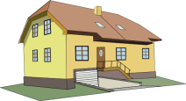](http://www.google.jo/url?sa=i&rct=j&q=&esrc=s&frm=1&source=images&cd=&cad=rja&uact=8&ved=0CAcQjRxqFQoTCIHr0u2vl8kCFUZGFAodHUkNTA&url=http://www.clipartlord.com/free-big-house-clip-art/&bvm=bv.107467506,d.d24&psig=AFQjCNHSxFiZMpwo-sMJbz86cLKO7p9c6g&ust=1447846816710355)Adjectives show the color :

I have a **yellow** skirt.

I have a **red** hat.

[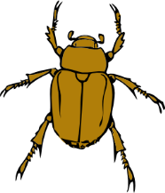](http://www.google.jo/url?sa=i&rct=j&q=&esrc=s&frm=1&source=images&cd=&cad=rja&uact=8&ved=0CAcQjRxqFQoTCLL2hYmwl8kCFYK3FAod30ECQQ&url=http://www.clipartsheep.com/clip-art-insect-exterminator-fotosearch-search-clipart/dT1hSFIwY0RvdkwyTnZiWEJ6TG1admRHOXpaV0Z5WTJndVkyOXRMMk52YlhBdlUxVkZMMU5WUlRFd05TOXBibk5sWTNRdFpYaDBaWEp0YVc1aGRHOXlYMzVVVDBKWE1ERTNPQzVxY0djfHc9MzEwfGg9MzcwfHQ9anBlZ3w/&bvm=bv.107467506,d.d24&psig=AFQjCNHRw4v7i1wCZtM6AG-ZCIVJeKU3ww&ust=1447846859535101)Adjectives show the size:

We live in a **big** house.

[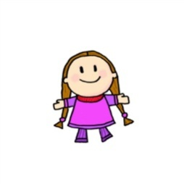](http://www.google.jo/url?sa=i&rct=j&q=&esrc=s&frm=1&source=images&cd=&cad=rja&uact=8&ved=0CAcQjRxqFQoTCMGs7b6wl8kCFcnVFAodR0kMRA&url=http://www.cliparthut.com/dorm-girls-clipart.html&bvm=bv.107467506,d.d24&psig=AFQjCNE9ElZZVjaLxI69njkZayk1hv0lKQ&ust=1447846961507074)[http://comps.canstockphoto.com/can-stock-photo_csp14380257.jpg](http://www.google.jo/url?sa=i&rct=j&q=&esrc=s&frm=1&source=images&cd=&cad=rja&uact=8&ved=0CAcQjRxqFQoTCKWXqp-wl8kCFUe5FAodi_IP8Q&url=http://www.canstockphoto.com/a-tall-boy-standing-14380257.html&bvm=bv.107467506,d.d24&psig=AFQjCNF3U4iVKnzDk5rGBdh6LF5nCWn1lQ&ust=1447846914861918)I see a **small** insect.

He is a **tall** boy.

She is a **short** girl.

Circle the adjectives:

|  |  |  |  |
| --- | --- | --- | --- |
| cat | big | door | sad |
| hospital | yard | three | short |
| purple | two | small | white |
| angry | five | tall | Hipoo |