|  |  |  |  |
| --- | --- | --- | --- |
| logo-trans | **Al Hijaz Private Schools │ CP Section** | | Primary_logo RGB |
| **Name: \_\_\_\_\_\_\_\_\_\_\_\_\_\_\_\_\_\_\_\_\_\_\_\_\_\_\_\_\_\_\_\_**  **Date: \_\_\_\_\_\_\_\_\_\_\_\_\_\_\_\_\_\_\_\_\_\_\_** | | **Math Revision Sheet 1** | **Teacher:Ghada Fawzi**  **Grade: 1( a,b)** |

**Q1: Write name fo each 3D :**

**( cube , rectangular prism , sphere , cone ,cylinder )**

|  |  |  |  |  |
| --- | --- | --- | --- | --- |
| **2748378_orig.png** | **2748378_orig.png** | **2748378_orig.png** | **2748378_orig.png** | **2748378_orig.png** |
|  | **\_\_\_\_\_\_\_\_** | **\_\_\_\_\_\_\_\_** | **\_\_\_\_\_\_\_\_** | **\_\_\_\_\_\_\_** |

**Q2 Draw :**

|  |  |  |  |
| --- | --- | --- | --- |
| **Square** | **Circle** | **Rectangle** | **Triangle** |

**Q3: Draw line of symmetry :**

**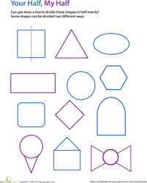**

**Q4:Recognize how each figures has moved.Write slide,flip, and turn:**

**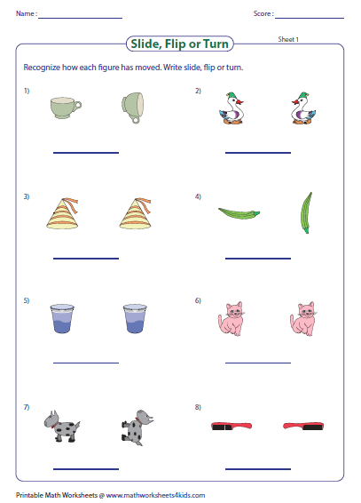**

**Q5:Shade the shapes which has equal parts :**

**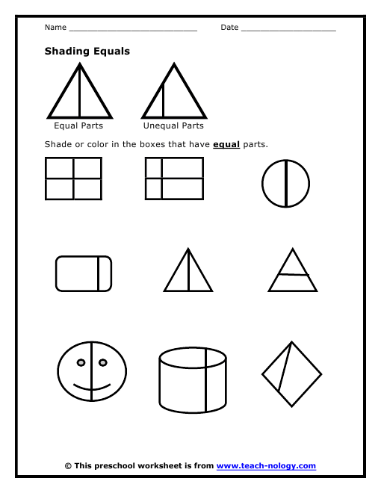**

**Q6:Write the time :**

**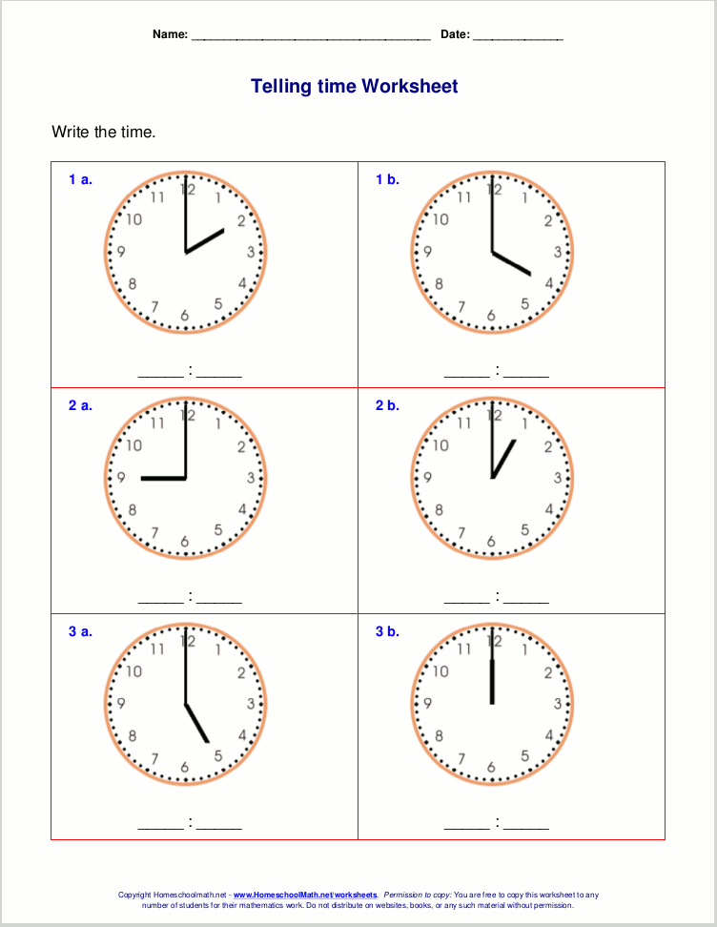**

**Q7: Draw the hands on the clock :**

**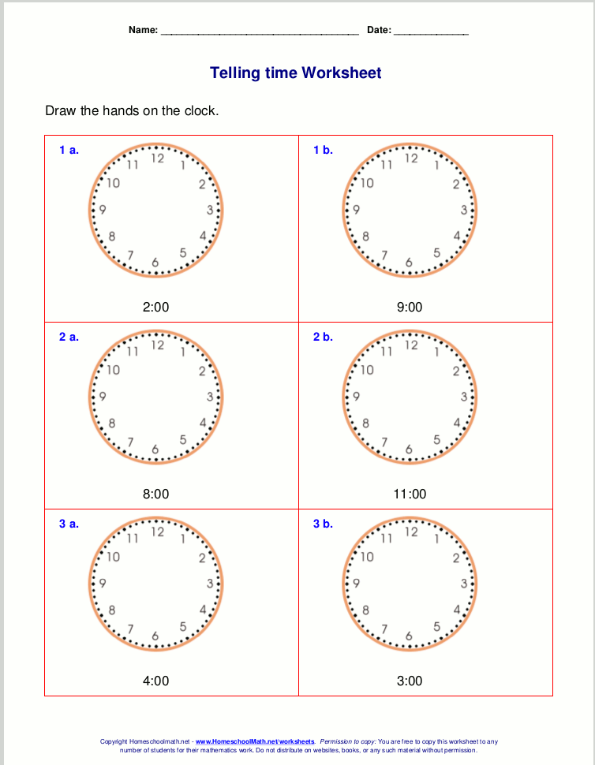**

**Q8:Which day come next :**

**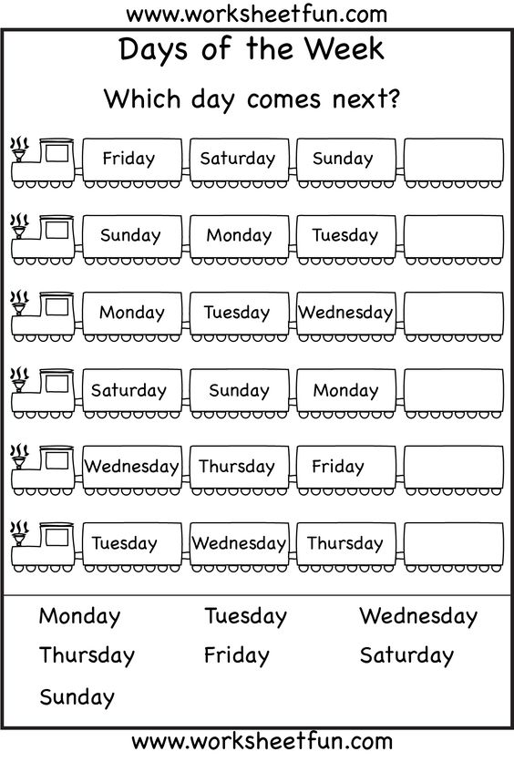**

Q9: Days of the week:

|  |
| --- |
| Sunday,Monday,Tuesday,Wednesday,Thursday,Friday,Saturday |
| Today is Monday.  What day is tomorrow ? \_\_\_\_\_\_\_\_\_\_\_\_\_\_\_\_\_\_\_\_\_\_\_\_\_\_\_\_\_\_\_    What day was yesterday?\_\_\_\_\_\_\_\_\_\_\_\_\_\_\_\_\_\_\_\_\_\_\_\_\_\_\_\_\_\_ |
| Today is Thursday.  What day is tomorrow ? \_\_\_\_\_\_\_\_\_\_\_\_\_\_\_\_\_\_\_\_\_\_\_\_\_\_\_\_\_\_\_    What day was yesterday?\_\_\_\_\_\_\_\_\_\_\_\_\_\_\_\_\_\_\_\_\_\_\_\_\_\_\_\_\_\_  Today is Tuesday  What day is tomorrow ? \_\_\_\_\_\_\_\_\_\_\_\_\_\_\_\_\_\_\_\_\_\_\_\_\_\_\_\_\_\_\_    What day was yesterday?\_\_\_\_\_\_\_\_\_\_\_\_\_\_\_\_\_\_\_\_\_\_\_\_\_\_\_\_\_\_ |

**Q10: Write the correct order :**

|  |  |
| --- | --- |
| 1- | January |
| 2- | March |
| 3- | October |
| 4- | June |
| 5- | February |
| 6- | November |
| 7- | April |
| 8- | October |
| 9- | July |
| 10- | December |
| 11- | September |
| 12- | May |

**Q11: Complete the statement by filling M for morning, A for afternoon , N for night**

**