

**The Hashemite Kingdom of Jordan**

**The Ministry of Education**

**AL-Hijaz Private Schools**

**Quality Assurance Section**

**Worksheet No. (5)**

|  |  |  |  |
| --- | --- | --- | --- |
| **Day:** | **Year: 2019 / 2020** | **Subject: English** | **Student’s Name:** |
| **Date: -9-2019** | **Semester: 1st** | **Topic: pronouns** | **Grade & Section:(4) A-B-C** |

|  |  |
| --- | --- |
| **A PRONOUN** | **is a word that takes the place of the noun.** |
| **A PRONOUN** | **is used to make the sentence sound better.**  **E.g. Tom is** a mail carrier**. He** carries a blue bag**.** |
| **A PRONOUN** | **is used to make the sentence shorter.**  **My dad and my uncle** went fishing.  **They** went fishing. |

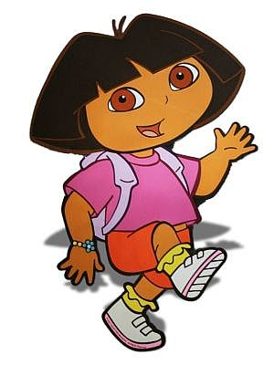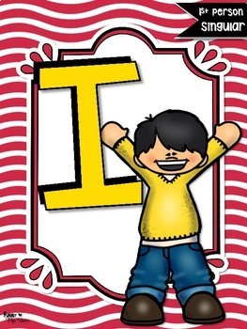

**She He**



**It You We**

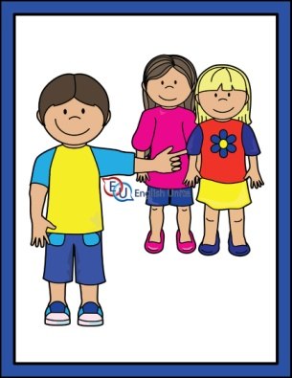



**They They They**

**Question one: -Replace the nouns with the correct pronouns**.

|  |  |  |
| --- | --- | --- |
| 1 | Mary |  |
| 2 | My sister and I |  |
| 3 | The cat |  |
| 4 | Rose and Anna |  |
| 5 | The board |  |
| 6 | The balls |  |
| 7 | Teacher Ali |  |
| 8 | The boats |  |

**Question two: -**

**Write the pronoun that could replace the underlined word(s) in each sentence.**

**1.** Where did Red Riding Hood go? -----------------------

**2.** I wonder if Dad knows the phone number! ---------------------

**3.** Martha and I had to leave early for school. --------------------

**4.** Albatrosses are the most amazing travellers**. ---------------**

**5.** The mouse is running. ----------------------------

**6.** Jane, Lisa, Beth, and Susan went to the game together. ------------------

**Teacher: - Hala Al-Azzah**