[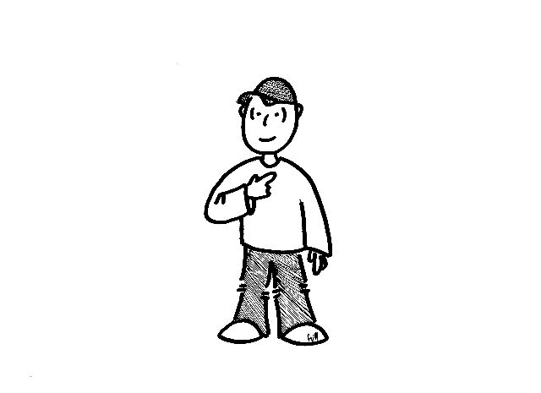](http://www.google.jo/url?sa=i&rct=j&q=&esrc=s&frm=1&source=images&cd=&cad=rja&uact=8&ved=0CAcQjRxqFQoTCPyfqcHJvMgCFUU7FAodsnsI9w&url=http://swifter.co/search/Personal+Pronouns+Exercises+With+Answers/&psig=AFQjCNEv6Ee5nyt7OAivX9JpslPVVMZHWA&ust=1444726954330866)I

You

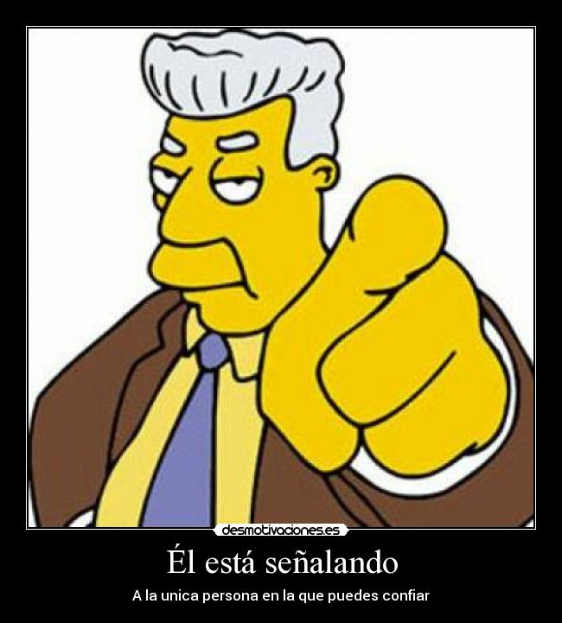

He

[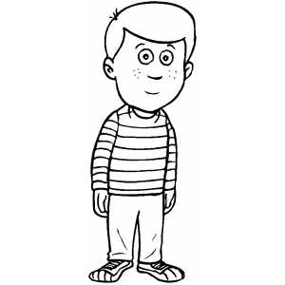](http://www.google.jo/url?sa=i&rct=j&q=&esrc=s&frm=1&source=images&cd=&cad=rja&uact=8&ved=0CAcQjRxqFQoTCNrPpofKvMgCFYPDFAodPQcPtA&url=http://www.freecoloringsheets.net/samples/Emotions/&bvm=bv.104819420,d.d24&psig=AFQjCNFVuZns2QsF1k9V3ATRyr7cZvgWSA&ust=1444727109740686)

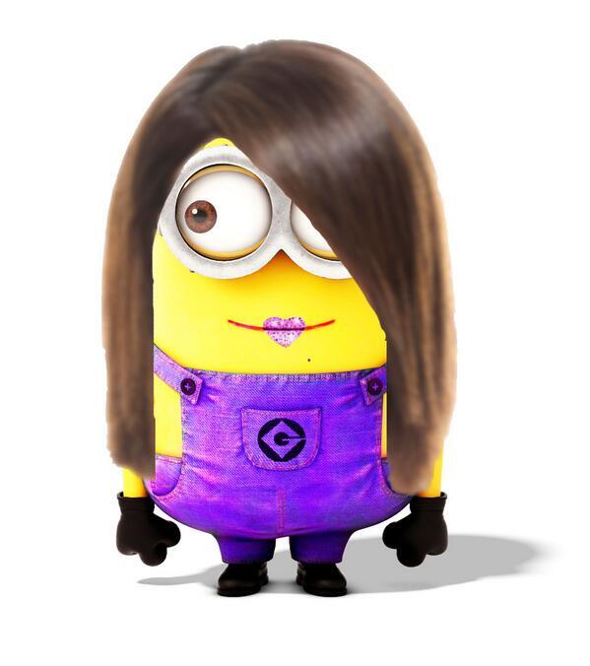 She

It

We

|  |  |
| --- | --- |
| [http://images.clipartpanda.com/open-clipart-21770-open-book-design.png](http://www.google.jo/url?sa=i&rct=j&q=&esrc=s&frm=1&source=images&cd=&cad=rja&uact=8&ved=0CAcQjRxqFQoTCN-j2snLvMgCFcZyFAodCEEEOw&url=http://www.clipartpanda.com/categories/open-book-clip-art-color&psig=AFQjCNFguAHQ5P0JtVhZSBY40QlNYaaRkw&ust=1444727441448986)http://sitiocreactivo.es/wp-content/uploads/2012/03/santa.jpgIt | [http://www.quia.com/files/quia/users/carrie%20markos/subjectpronouns/they](http://www.google.jo/url?sa=i&rct=j&q=&esrc=s&frm=1&source=images&cd=&cad=rja&uact=8&ved=0CAcQjRxqFQoTCJWX_YTOvMgCFYPWFAodkpoJlQ&url=http://www.quia.com/jg/688610list.html&psig=AFQjCNF4y30all6_qLfzAXqsupeccSETpg&ust=1444728110813721)They |
| [http://tx.english-ch.com/teacher/gena/you-plural.jpg](http://www.google.jo/url?sa=i&rct=j&q=&esrc=s&frm=1&source=images&cd=&ved=0CAcQjRxqFQoTCKTEs9LMvMgCFcNSFAodDvYN6A&url=http://tx.english-ch.com/teacher/gena/home/quantifiers/&psig=AFQjCNELMxmqHvuMkGYcpyzYaK9xAfmXLA&ust=1444727802056218)You | [http://www.quia.com/files/quia/users/carrie%20markos/subjectpronouns/we-masculine](http://www.google.jo/url?sa=i&rct=j&q=&esrc=s&frm=1&source=images&cd=&cad=rja&uact=8&ved=0CAcQjRxqFQoTCJv1jfbMvMgCFUNeFAodPYoMqQ&url=http://www.quia.com/jg/688610list.html&psig=AFQjCNELMxmqHvuMkGYcpyzYaK9xAfmXLA&ust=1444727802056218)We |