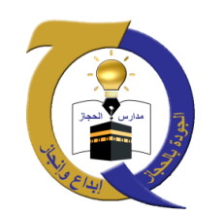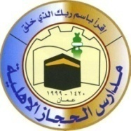

**The Hashemite Kingdom of Jordan**

**The Ministry of Education**

**AL-Hijaz Private Schools**

**Quality Assurance Section**

**Worksheet No. (1)**

|  |  |  |  |
| --- | --- | --- | --- |
| **Day:** | **Year: 2019 / 2020** | **Subject: English** | **Student’s Name:** |
| **Date: -9-2019** | **Semester: 2nd** | **Topic: Nouns** | **Grade & Section:(4) A-B-C** |

Nouns

**A noun is a word that names people, places, animals or things.**

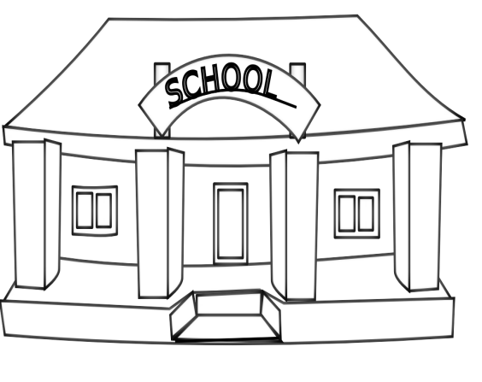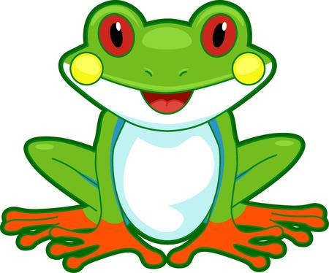

**A place an animal**

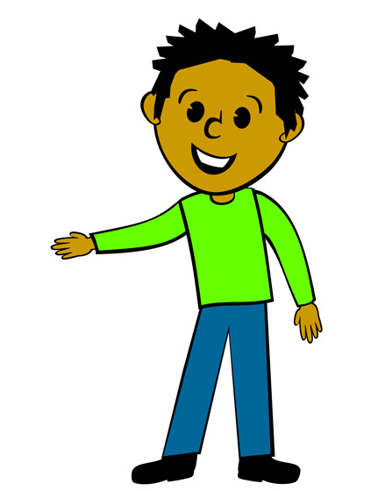

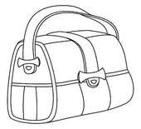

**A thing A person**

**Place the following nouns in the correct category in each of the balloons below:**

airport teacher pencil beach chair

cow computer doctor brother crocodile

lady school car snake father masjid fish park cat sister

mother bed monkey library dress

People

Animals

Places

Things



**Teacher: - Hala Al-Azzah**