|  |  |  |  |
| --- | --- | --- | --- |
| logo-trans | **Al Hijaz Private Schools │ CP Section** | | Primary_logo RGB |
| **Name: \_\_\_\_\_\_\_\_\_\_\_\_\_\_\_\_\_\_\_\_\_\_\_\_\_\_\_\_\_\_\_\_\_\_**  **Grade: ( 2 )** | | **Math**  **Revision Sheet 2** | **Date: / 11 / 2018**  **Teacher: Ghada** |

**Q1: fill in missing numbers :**

|  |
| --- |
| **67** |
| |  |  |  |  |  |  |  |  |  | | --- | --- | --- | --- | --- | --- | --- | --- | --- | |  |  |  |  |  | **12** | **10** | **8** | **6** | |
| |  |  |  |  |  |  |  | | --- | --- | --- | --- | --- | --- | --- | |  |  |  | **20** | **25** | **30** | **35** | |

**Q2:Compare the numbers and use , , or = :**

|  |  |
| --- | --- |
| **18 19** | **62 62** |
| **51 77** | **87 78** |

**Q3 : Order the numbers from smallest to largest :**

|  |  |  |  |
| --- | --- | --- | --- |
| **90** | **37** | **9** | **33** |
|  |  |  |  |

**Q4 : Round these number to nearest 10 :**

**13**

**45**

**99**

**Q5: How many ice-creams do you think there are ? Circle the correct answer.**

**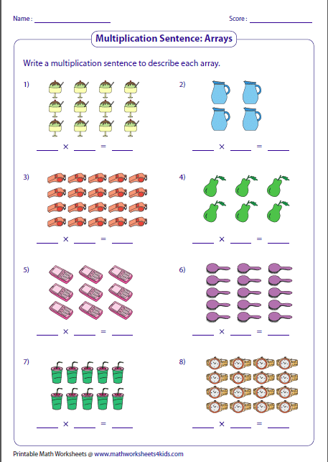**

**50 100 40**

**Q5: Circle the two numbers that have been sorted incorrectly:**

**Q6 : Skip count in 3s :**

**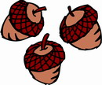**

|  |  |  |  |  |  |  |
| --- | --- | --- | --- | --- | --- | --- |
|  |  |  |  |  |  |  |

**study hard !**