|  |  |  |  |
| --- | --- | --- | --- |
| logo-trans | **Al Hijaz Private Schools │ CP Section** | | Primary_logo RGB |
| **Name: \_\_\_\_\_\_\_\_\_\_\_\_\_\_\_\_\_\_\_\_\_\_\_\_\_\_\_\_\_\_\_\_**  **Grade: ( 1 ) a , b** | | **phonics worksheet # ( 36 )** | **Teacher: Rawan** |

**\* Practise saying and writing the following sounds:**

**Y y /y/**

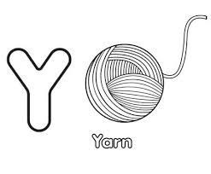

**yell yarn**

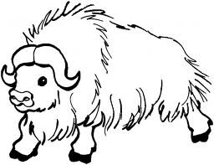

**yawn yak**

**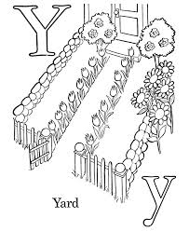**

**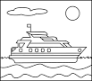**

**y yacht yard**