|  |  |  |  |
| --- | --- | --- | --- |
|  | **Al Hijaz Private Schools │ CP Section** | | Primary_logo RGB |
| **Name: \_\_\_\_\_\_\_\_\_\_\_\_\_\_\_\_\_\_\_\_\_\_**  **Date: \_\_\_\_\_\_\_\_\_\_\_\_\_\_\_\_\_\_\_\_\_\_\_** | | **Math worksheet** | **Teacher: Ghada Fawzi**  **Grade: 1 (a,b)** |

**Write the missing numbers .Look for patterns:**

**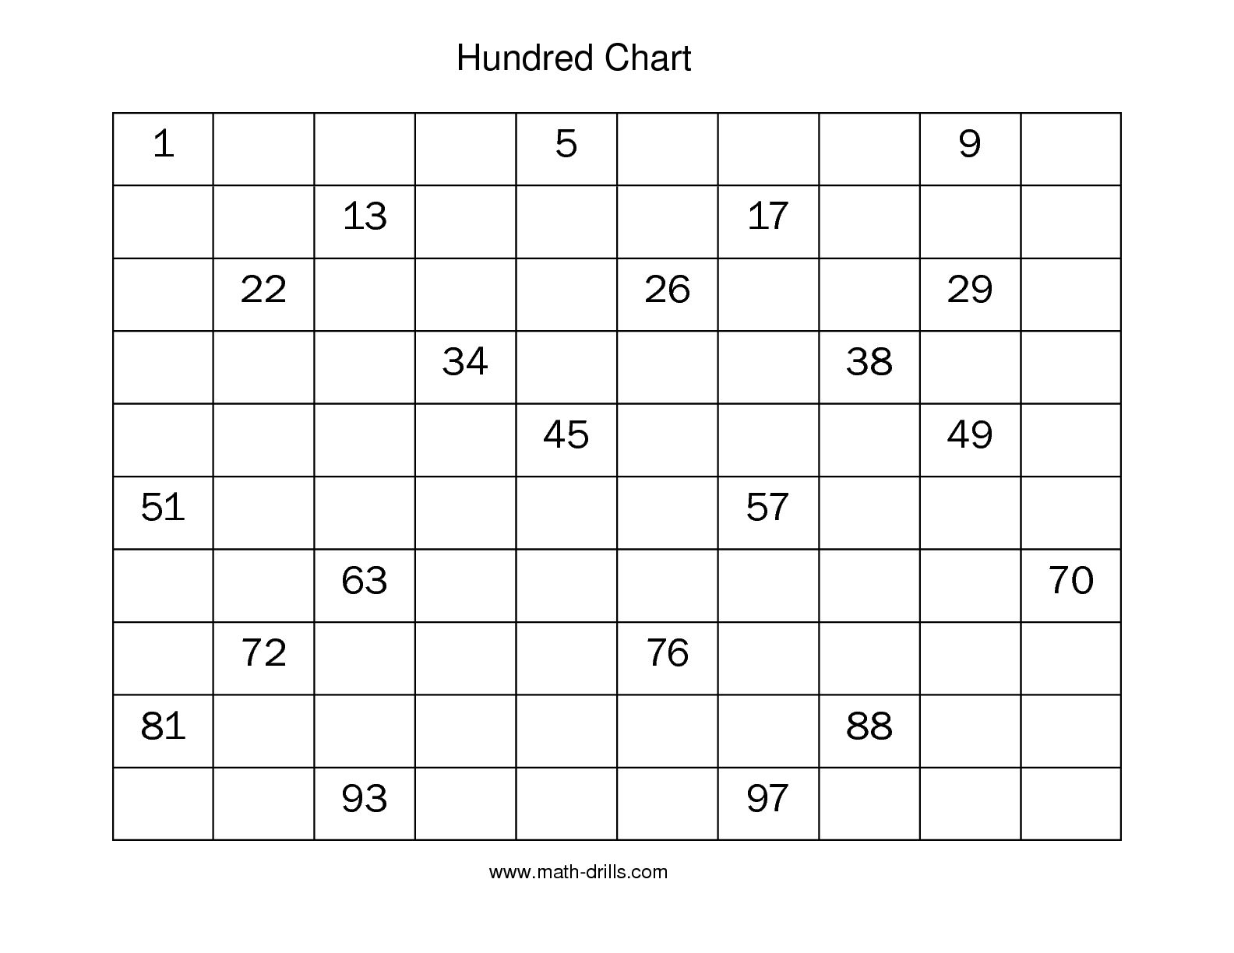**

**Use the hundred chart above to count back by 1s**

22, 23, 24 ,\_\_\_\_,\_\_\_\_,\_\_\_\_,28 ,\_\_\_\_ .

51, 52, \_\_\_, \_\_\_, \_\_\_\_, 56, \_\_\_\_\_, 58.