|  |  |  |  |
| --- | --- | --- | --- |
| logo-trans | **Al Hijaz Private Schools │ CP Section** | | Primary_logo RGB |
| **Name: \_\_\_\_\_\_\_\_\_\_\_\_\_\_\_\_\_\_\_\_\_\_\_\_\_\_\_\_\_\_**  **Grade: ( 1 ) a , b** | | **Use of English**  **worksheet ( 39 )** | **Teacher: Rawan** |

***WHAT ACHES YOU!***

**TASK : Match the picture with the correct health problem.**

**[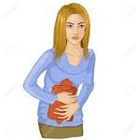](http://www.google.jo/url?url=http://www.123rf.com/clipart-vector/aches.html&rct=j&frm=1&q=&esrc=s&sa=U&ved=0ahUKEwje-8uS5eXLAhULXBQKHQEQA14QwW4ILTAL&usg=AFQjCNEqlfYrrunSU4znZWz8n20a0EBvBw)**

**1. I have a headache.**

[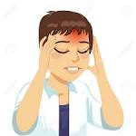](http://www.google.jo/url?url=http://www.123rf.com/clipart-vector/headache_pain.html&rct=j&frm=1&q=&esrc=s&sa=U&ved=0ahUKEwjnuNTO5eXLAhVBaRQKHfOKBXIQwW4IKzAL&usg=AFQjCNFHoH5erFqGOg5-RhzYazW-ZMzHGg)

**2. She has a stomachache.**

[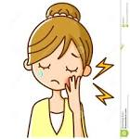](http://www.google.jo/url?url=http://clipartfreefor.com/files/1/18911_business-clip-art.html&rct=j&frm=1&q=&esrc=s&sa=U&ved=0ahUKEwiT-9eq5eXLAhXHbhQKHRy3Bs4QwW4IHTAD&usg=AFQjCNH7oUY_zLDc6CmTXd74rpyz8d8vQA)**3. He has a backache.**

****

**4. She has a toothache.**

**[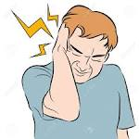](http://www.google.jo/url?url=http://www.123rf.com/stock-photo/earache.html&rct=j&frm=1&q=&esrc=s&sa=U&ved=0ahUKEwiU-6P74OfLAhVGPxoKHcFUAX0QwW4IFzAB&usg=AFQjCNEFDiyCRkVhX_N4vheRbJxnWkHiOw)**

**5. He has an earache.**

**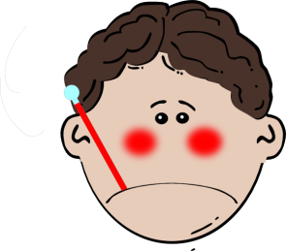6. He has a broken leg.**

**[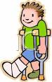](http://www.google.jo/url?url=http://www.clipartpanda.com/categories/crutch-20clipart&rct=j&frm=1&q=&esrc=s&sa=U&ved=0ahUKEwjKg6Ww5OXLAhUIVBQKHbUhDIIQwW4IKzAL&usg=AFQjCNHPiEYoxBFd8bHcJ81WAb8rxVLguQ)**

**7. He has a cold.**

**[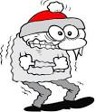](http://www.google.jo/url?url=http://worldartsme.com/winter-cold-clipart.html&rct=j&frm=1&q=&esrc=s&sa=U&ved=0ahUKEwjtr47o4-XLAhUKXRQKHUmyBiQQwW4IGzAD&usg=AFQjCNECVuAFyGAeRZcIQ33T_BSe3RJXxQ)**

**8. He has a fever.**

**[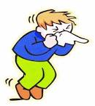](http://www.google.jo/url?url=http://cliparts.co/cold-and-flu-pictures&rct=j&frm=1&q=&esrc=s&sa=U&ved=0ahUKEwjhi8eP5OXLAhWDxRQKHbxYDlM4KBDBbggbMAM&usg=AFQjCNFbl2LwrLNkUFwYKol_PfkY5t4Yew)**

**9. She has a sore throat.**

**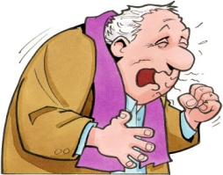**

**10. He has a cough.**

**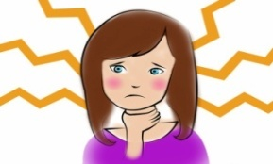**

**11. He has a runny nose.**

**[](http://www.google.jo/url?url=http://worldartsme.com/cut-finger-clipart.html&rct=j&frm=1&q=&esrc=s&sa=U&ved=0ahUKEwj-6Pqd5OXLAhXC0RQKHYCtDwYQwW4ILTAM&usg=AFQjCNGNJRW5gr2qVpWUSSJPUVKm496vaQ)**

**12. He has a cut.**

**Dear student, tell me when you have any of the above!**

**Your Caring Teacher, Miss Rawan**