|  |  |  |  |
| --- | --- | --- | --- |
| logo-trans | **Al Hijaz Private Schools │ CP Section** | | Primary_logo RGB |
| **Name: \_\_\_\_\_\_\_\_\_\_\_\_\_\_\_\_\_\_\_\_\_\_\_\_\_\_\_\_**  **Grade: ( 1 ) a , b** | | **Math**  **Revision sheet (2)** | **Date: / 11 / 2018**  **Teacher: Ghada** |

**Q1: Order the numbers from smallest to largest:**

**13 10 16**

|  |  |  |
| --- | --- | --- |
|  |  |  |

**Q2: Guess how many are there in box :**

|  |
| --- |
| **imagesCAEQWR92.jpg imagesCAEQWR92.jpg imagesCAEQWR92.jpg imagesCAEQWR92.jpg imagesCAEQWR92.jpg imagesCAEQWR92.jpg imagesCAEQWR92.jpg imagesCAEQWR92.jpg**  **imagesCAEQWR92.jpg imagesCAEQWR92.jpg imagesCAEQWR92.jpg imagesCAEQWR92.jpg imagesCAEQWR92.jpg imagesCAEQWR92.jpg imagesCAEQWR92.jpg imagesCAEQWR92.jpg** |

**Estimate: Count:**

**Q3: Fill in missing numbers:**

* **Count by 2s :**

|  |  |  |  |  |  |
| --- | --- | --- | --- | --- | --- |
| **6** | **8** |  |  |  |  |

|  |  |  |  |  |  |
| --- | --- | --- | --- | --- | --- |
| **7** | **9** | **11** |  |  |  |

* **Count by 10s :**

|  |  |  |  |  |
| --- | --- | --- | --- | --- |
| **40** | **50** |  |  |  |

|  |  |  |  |  |
| --- | --- | --- | --- | --- |
| **3** | **13** |  |  |  |

* **1 or 10 more or less :**

**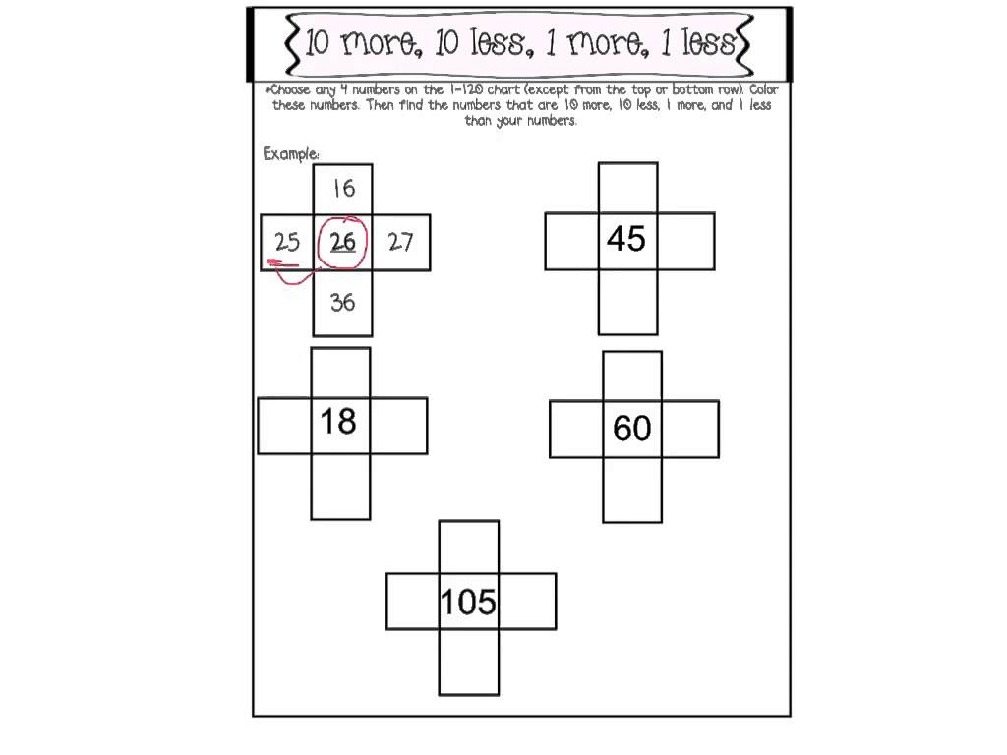**

* **Write the ordinal number :**

|  |  |  |  |  |  |  |  |  |  |
| --- | --- | --- | --- | --- | --- | --- | --- | --- | --- |
| **1st** |  |  | **4th** |  |  | **7th** |  | **9th** |  |

* **Fill in the missing 10 or 1**

**92**

**Q4: Fill in using numbers in box. you can use the number more than once :**

|  |
| --- |
| **3 6 9 12 18 20 25** |

|  |  |  |
| --- | --- | --- |
| **Less than** | **Number** | **More than** |
|  | **19** |  |
|  | **4** |  |

**Q5 : Write the number shown :**

**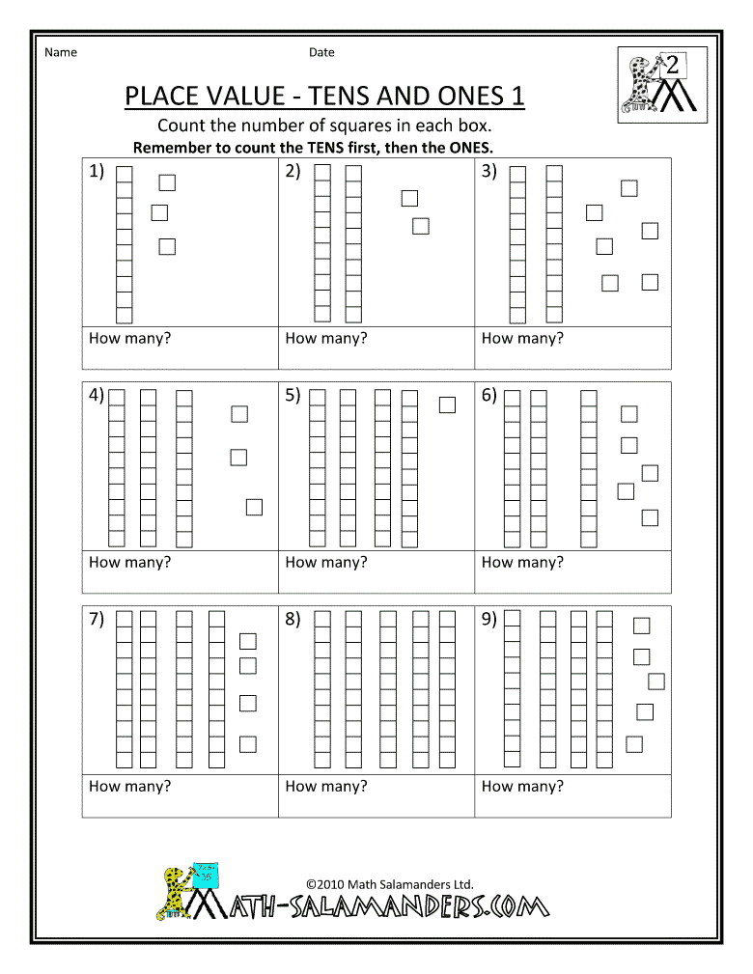\_\_\_\_\_\_\_\_\_\_\_\_\_\_\_\_\_\_\_**

** \_\_\_\_\_\_\_\_\_\_\_\_\_\_\_**

**^^^^^^^^^^^^^^^^^^^^^^^^^^^^^^^^^^^^^^^^^^^^**

**Study Hard**